**Help topics covered:**

* How to properly change events within CENTRG1_PlayIn_RealPMU.pwb case file?
* How to change timestep of PlayIn simulation?
* How to change length of PlayIn simulations?
* How to access log to see errors regarding error from PW simulation?
* How to run a contingency for a Full WECC simulation within PW?
* How to turn on AutoCorrect to automatically fix parameters for a transient stability run so it doesn’t abort a run?
* How to setup another event from the real PMU Data provided for CENTR G1?
* Location of All the Events used for PW PlayIn?

How to properly change events within CENTRG1_PlayIn_RealPMU.pwb case file?

* After a run of the SetupCase_CENTRG1.m function within Matlab which sets up the powerflow to provide proper P, Q, and voltages for the start of the dynamic simulation, the new PlayInData.aux needs to be read in then checked to see if the new event data is being played.

1. Open CENTRG1_PlayIn_RealPMU.pwb and make sure within Model Explorer which is under the Case Information tab that the CENTR P1 has the appropriate P, Q, and V for the event under Generators under the Network folder. All of these settings should be saved from a successful call of the SetupCase_CENTRG1.m function.
2. Make sure the WritePlayInAux.m function has been called appropriately which will overwrite the PlayInData.aux file containing the new event data.
3. Within PowerWorld GUI, go to the Add Ons Tab and open up the Transient Stability Analysis menu. Next, go to the File tab and then click Load Auxiliary then select the PlayInData.aux. In the Transient Stability Analysis menu, hit Run Transient Stability. The plot generated should now match the V and F of the event file.
4. Save the case by hitting Save Case under the File Tab. I typically skip the comment section that follows.
5. Can check to see that the event and the PlayIn simulations match by going into the residual_Jacobian_PowerWorld_RealPMU.m function and uncommenting the plots at the end of the script and put a breakpoint at the end.

How to change timestep of PlayIn simulations?

1. Open CENTRG1_PlayIn_RealPMU.pwb.
2. Within PowerWorld GUI, go to the Add Ons Tab and open up the Transient Stability Analysis menu. Change the step size to the new desired value.
3. Save the case by hitting Save Case under the File Tab. I typically skip the comment section that follows.

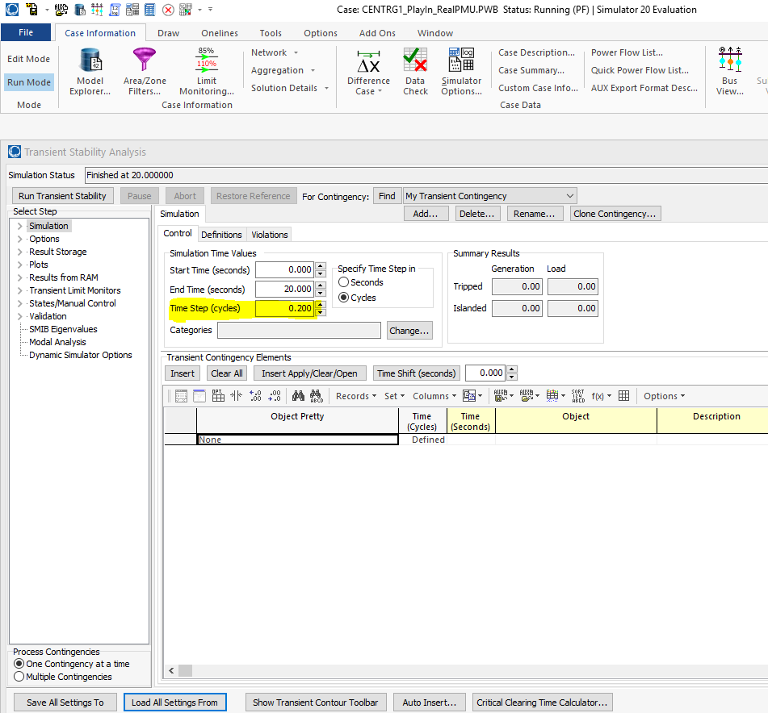

How to change length of PlayIn simulations?

1. Open CENTRG1_PlayIn_RealPMU.pwb.
2. Within PowerWorld GUI, go to the Add Ons Tab and open up the Transient Stability Analysis menu. Change end time to desired value.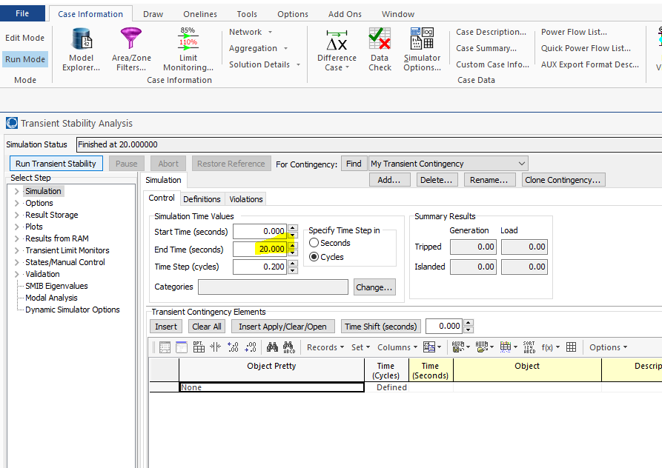
3. Have to delete old PlayIn Data which is a different size. Open Case Information then open Model Explorer and hit the transient stability folder. Choose PlayIn Configuration. Right click and delete the old PlayInData.

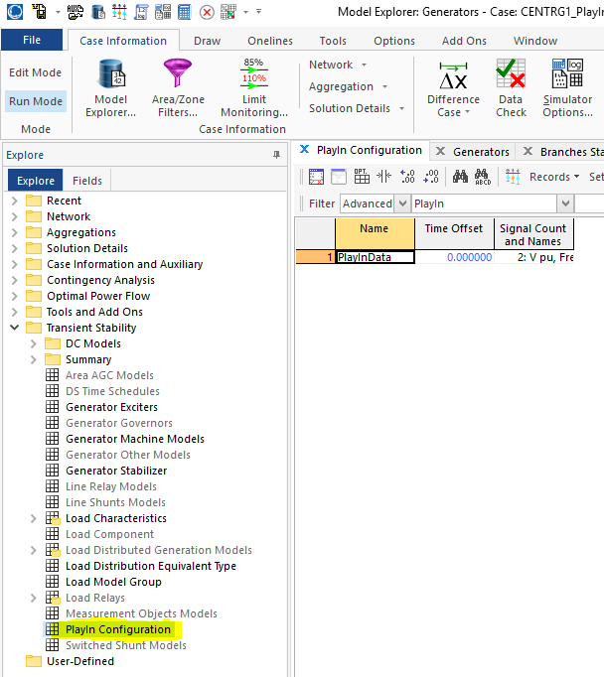

1. Load the new PlayInData going to File and hitting the Load Auxiliary tab. Choose the new PlayInData.aux. It should show up in the same area that the old one was located.
2. Need to reference the PlayIn Generator back to the new PlayInData. Open Case Information then open Model Explorer and hit the Network folder. Choose Generators. Right click and pull up the Dialog on the PlayIn Generator(CENTR P1). Go to the Stability submenu and choose the PlayInData in the highlighted box.

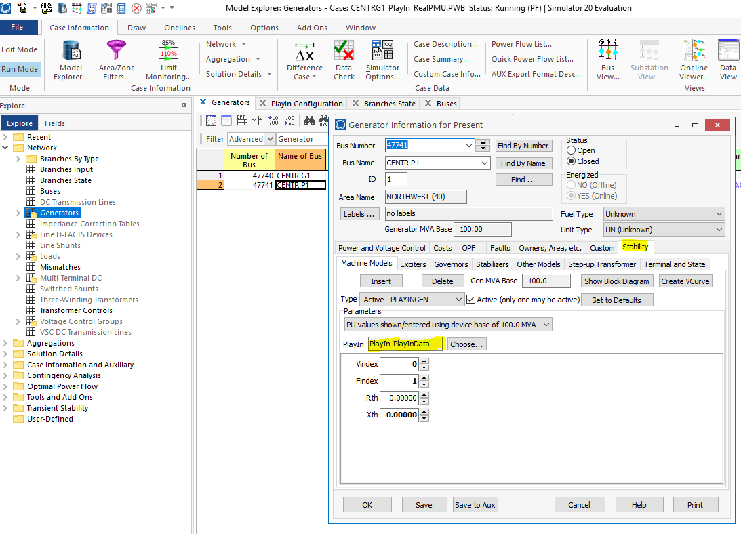

1. Save the case by hitting Save Case under the File Tab. I typically skip the comment section that follows.

How to access log to see errors regarding error from PW simulation?

1. Open CENTRG1_PlayIn_RealPMU.pwb.
2. Go to File and Click Load Auxiliary to load in the LoadDYD_RunPlayIn_RealPMU.aux file. It will load in the most recently written dyd file and run a transient stability simulation.
3. Errors should be seen in the log which is located under the Tools Tab.

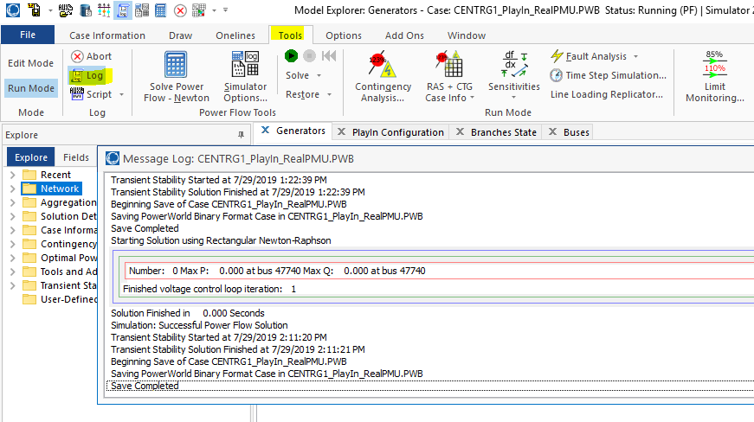

1. You can also run a transient stability from the GUI after you loaded the Aux file from step 2. The GUI will provide a more detailed description of the error. Do this by opening the Transient Stability Analysis button under the Add Ons tab. Then hit Run Transient Stability and all of the validation errors and violations should be listed.

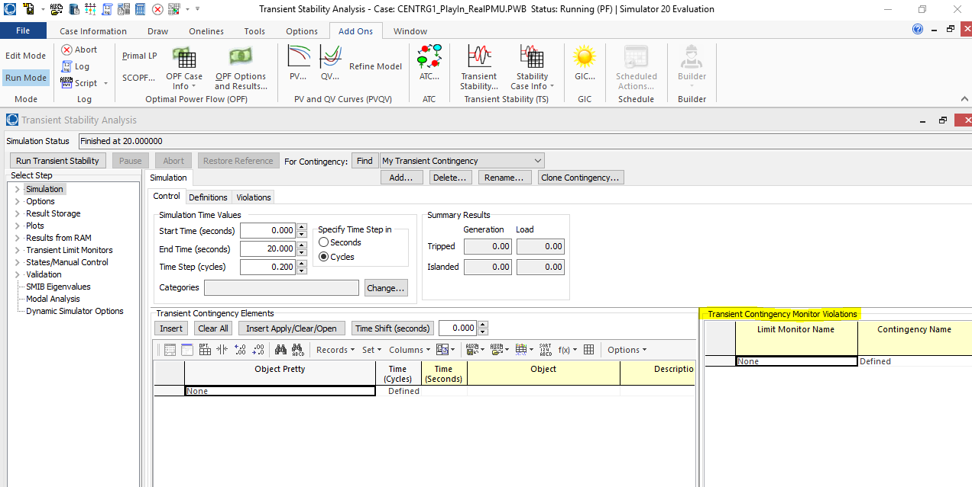

How to run a contingency for a Full WECC simulation within PW?

Option 1: Run from GUI and save data as a .CSV file.

1. Open 16ls1a.pwb within PowerWorld GUI.
2. Within PowerWorld GUI, go to the Add Ons Tab and open up the Transient Stability Analysis menu. Create a Clone of one of the contingencies (to get all the same settings for plotting, etc). Rename the contingency to something more appropriate. Delete old contingencies elements in the Transient Contingency Elements Menu so that new contingency is empty. Insert contingencies that you want to see the effects of on CENTG1. Adjust Timestep and Run Time to desired values.

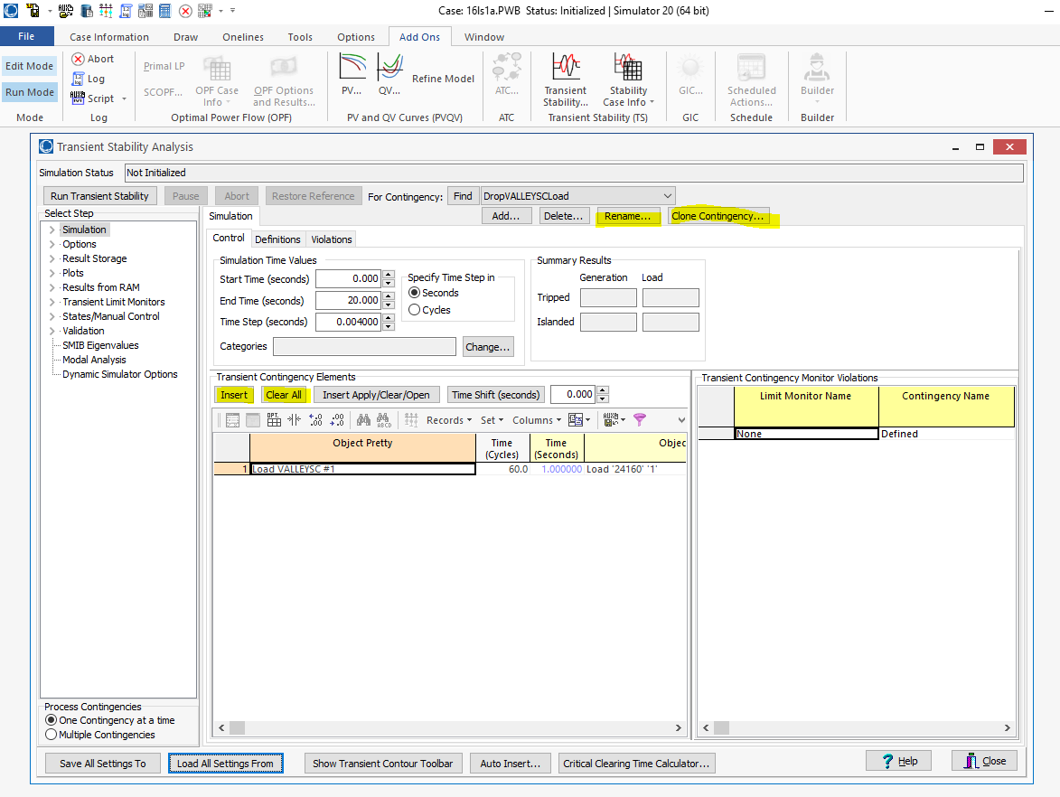

1. Click File save case so that the contingency will be saved in the 16ls1a.pwb case file.
2. Click Run Transient Stability. (Takes awhile to complete run)
3. When simulation is done, a plot w/ the name CENTG1_EventData will be generated. Right click on chart and select Export Chart with Options. Go to the Data tab and click save. Change the save as type to Comma delimited text files (I had trouble with other types). Save in desired place.

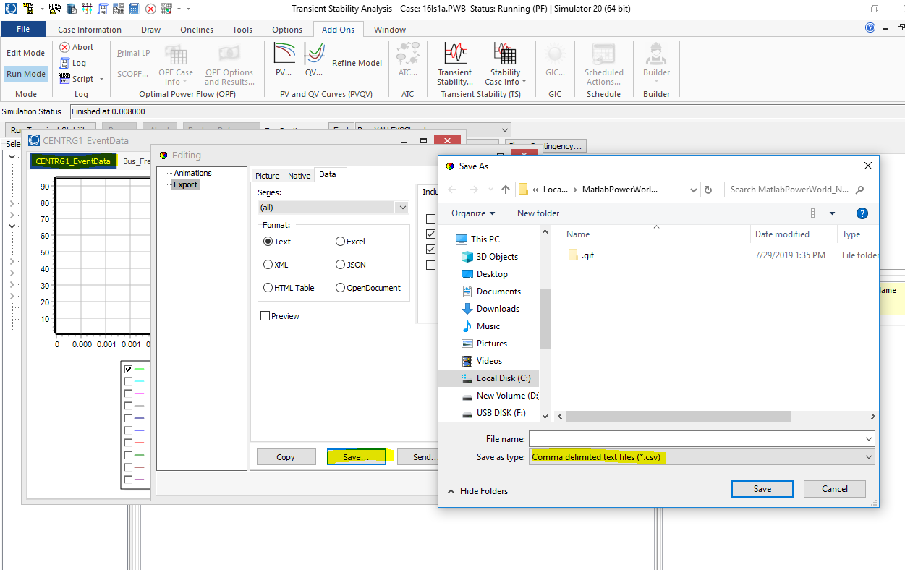

Option 2: Run from Matlab and get data directly into Matlab. (It took me a couple hours to run an event last time I ran it from Matlab for some reason. May have had to run all the contingencies that were listed..)

1. Make sure you have the GetAllContingencyData.m , Run1Contingency.aux , and 16ls1a.pwb in the same folder.
2. Within PowerWorld GUI, go to the Add Ons Tab and open up the Transient Stability Analysis menu. Create a Clone of one of the contingencies (to get all the same settings for plotting, etc). Rename the contingency to something more appropriate. Delete old contingencies elements in the Transient Contingency Elements Menu so that new contingency is empty. Insert contingencies that you want to see the effects of on CENTG1. Adjust Timestep and Run Time to desired values.



1. Click File save case so that the contingency will be saved in the 16ls1a.pwb case file.
2. Close the 16ls1a.pwb case file in the GUI and reopen and verify that the contingency that you made is still in the Transient Stability Analysis menu.
3. Modify the Run1Contingency.aux so that the TSSolve command is now referencing the name of your contingency. **CASE OF THE NAME IS IMPORTANT**. Save the Run1Contingency.aux.
4. Open the GetAllContingencyData.m Script. Most of it should be commented out.
5. Make sure the path for the filename is referenced to the Run1Contingency.aux file.
6. Change the newCtgName to the **SAME** contingency name that you changed within the Run1Contingency.aux.
7. Leave the objFieldList as {'"Plot ''CENTRG1_EventData''"' };
8. Change the data.Description to something describing this event.
9. Change the name of the .mat file to identify this event.
10. Run Matlab script which will call and open 16ls1a.pwb, then run the Run1Contingency, then load the data into Matlab.

* How to turn on AutoCorrect to automatically fix parameters for a transient stability run so it doesn’t abort a run?

1. Find the PowerWorld_WriteDYD_Run_RealPMU.m file then uncomment this portion of code.

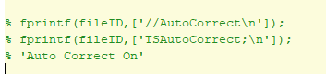

* How to setup another event from the real PMU Data provided for CENTR G1?

1. Locate the SetupMatFilePlayIn_centralia_data.m file within the PMU Data folder.
2. Change the start and end time in the script to capture the desired event.

* Location of All the Events used for PW PlayIn?

1. PowerWorld Files\FULL WECC and CENTG1 PlayIn Should contain all of the .mat files that I ran in the Full WECC from PowerWorld.
2. PowerWorld Files\CENTRG1 Real PMU Data Contains all of the .mat files for the Real PMU data and the start and end times are included in the name.